Lab setup for Fundamentals of Weblogic Server

**Hardware Requirements**

* **CPU:** i Core 3 or higher (64 bit hardware platform)
* **Hard** Disk: 250 GB Minimum
* **OS:** Windows 10 (x64 bit)
* **RAM:** 8 GB Minimum
* **Others:** Keyboard, Mouse, LAN Connectivity
* **Internet:** Wi-Fi enabled with Good internet connectivity (More than 5MBPS)
* **Permission:** Admin rights to download and install software’s & permission to download maven dependencies & plugins in VS Code

**Software Requirement:**

* JDK 17 or later
* Weblogic Server 14c

JDK 17 Downloading & Installing Steps

1. Visit the below link

<https://www.oracle.com/java/technologies/javase/jdk17-archive-downloads.html>

1. Scroll down to locate Java SE Kit 17.0.1.0

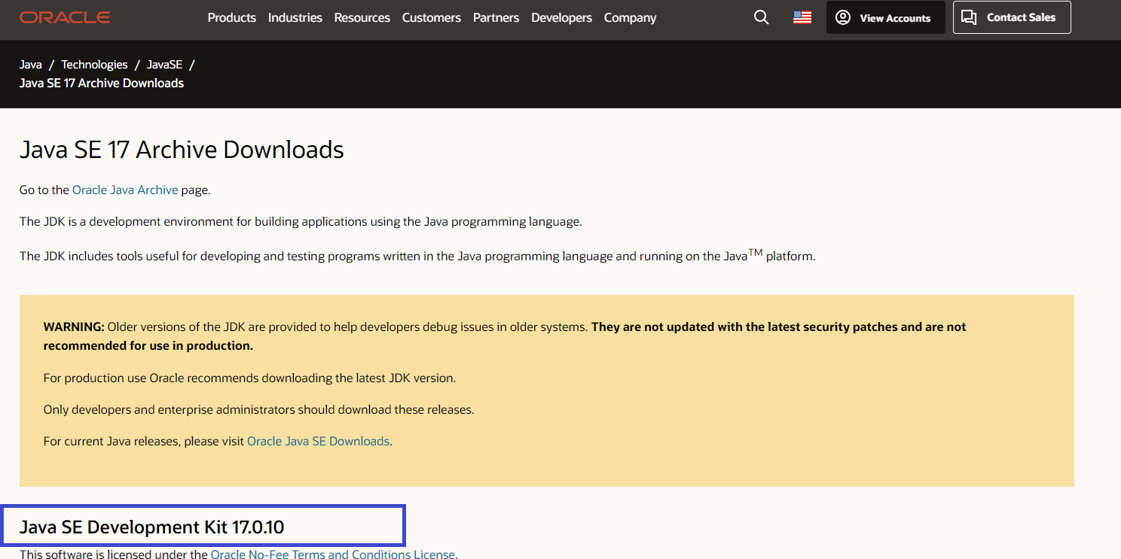

1. Scroll down to find Windows x64 MSI Installer

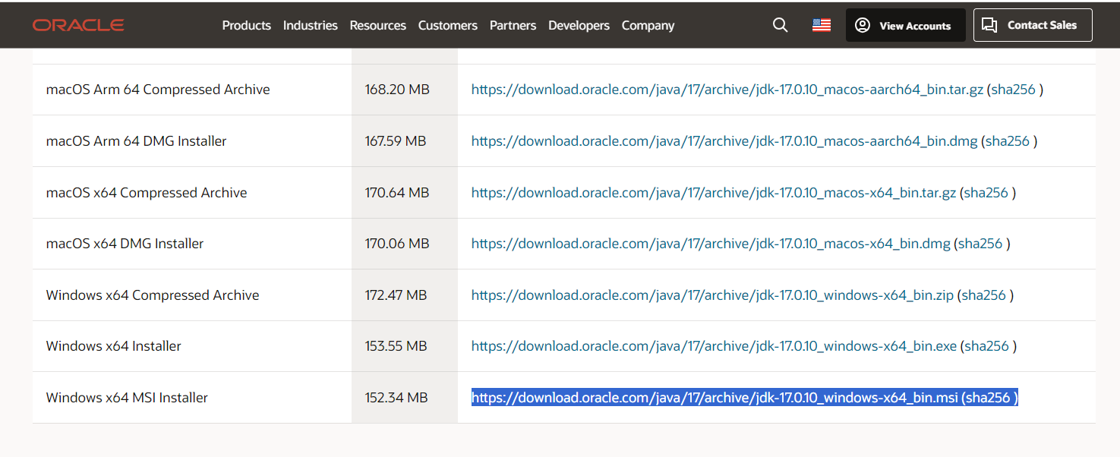

1. Now click on the Highlighted link <https://download.oracle.com/java/17/archive/jdk-17.0.10_windows-x64_bin.msi>
2. Above link downloads the JDK Wait for the download to complete
3. Locate the downloaded file JDK-17.0.10_windows-x64_bin & double click

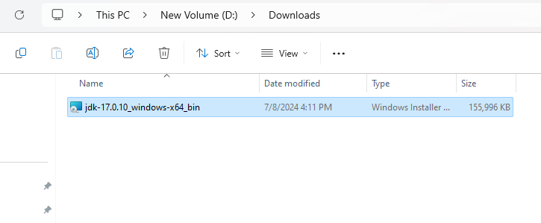

1. Double click on the JDK-17.0.10_windows-x64_bin file which starts installing and shows the below dialog

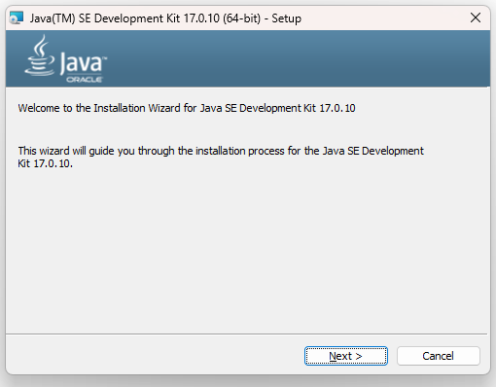

1. Click Next

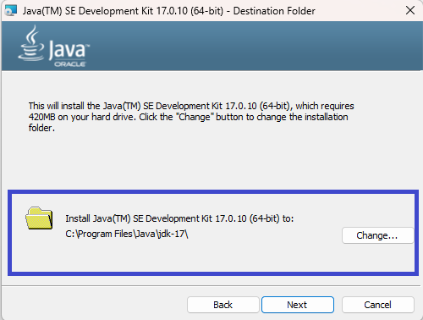

1. Click Next and wait, you will get a installation successful dialog as below

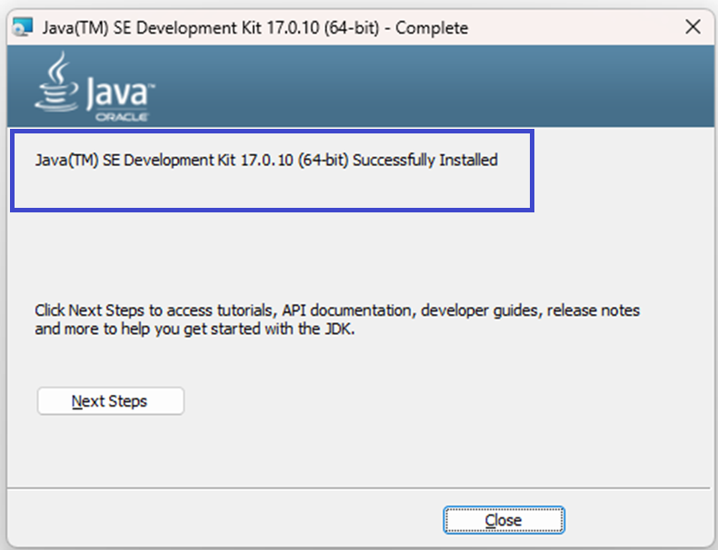

1. Now you click on Close.
2. Below folder will be created in **C:\Program Files\Java**

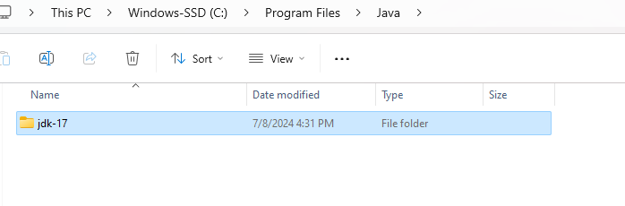

1. Add **C:\Program Files\Java\jdk-17\bin** to the system path
2. Go to File Explorer & Right Click on This PC and navigate to the Properties

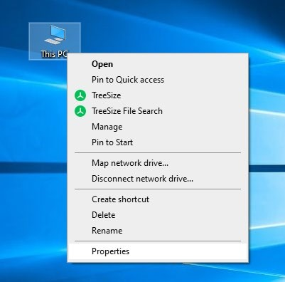

1. You will directed to the System Settings, there you will see Advanced System Settings as below.

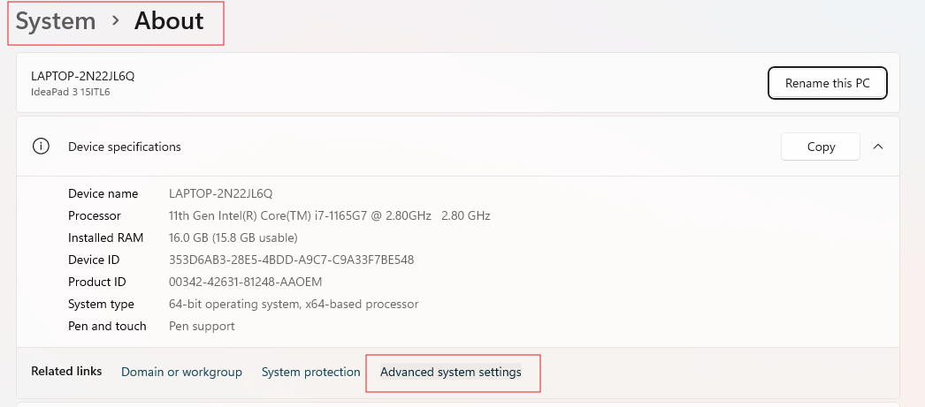

1. Click on the Advanced System Settings & you will see below dialog

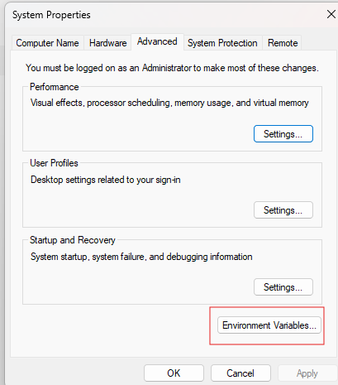

1. Click on the Environment Variables, you will get below dialog

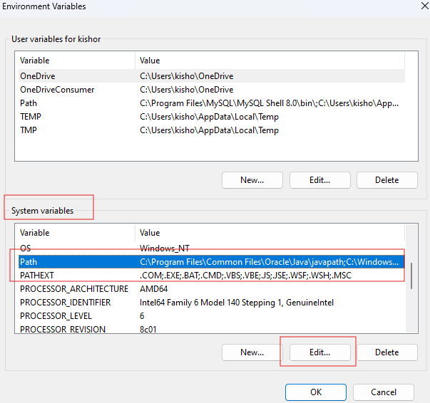

1. Select Path & Click on Edit button in the System Variables, you will get the dialog as below

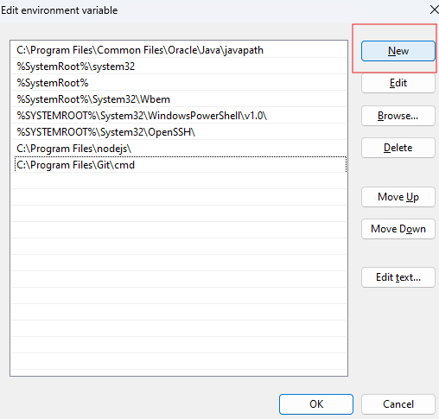

1. Click on you get an empty text box which looks as below

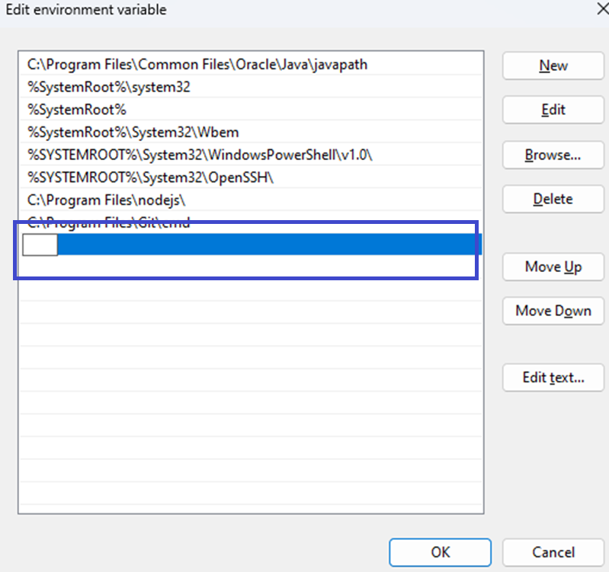

1. Paste the path of **C:\Program Files\Java\jdk-17\bin** in it

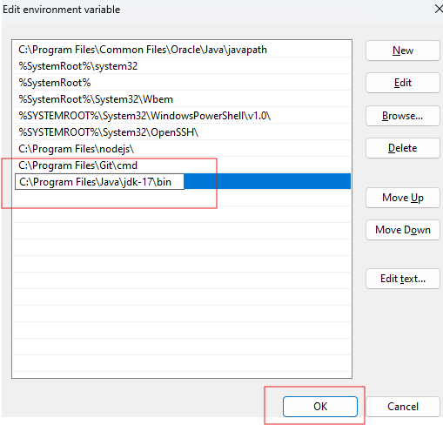

1. Click Ok, and again click Ok to close all the windows which were opened by clicking “Advanced System Settings” then you need to click Ok on other dialog boxes.
2. Open the command prompt and run the command one by one
   1. javac -version
   2. java -version
3. You will see the version numbers as below

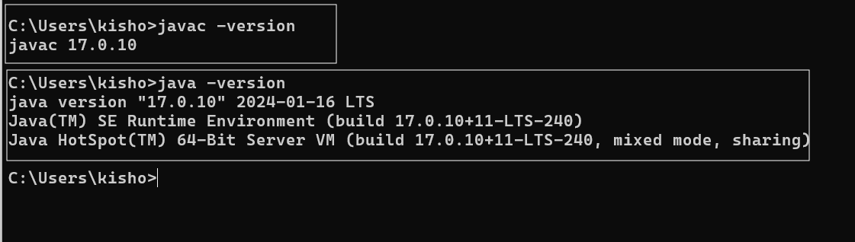

Note: If you see command not found on javac or java you need to check their spellings or redo the steps explained from point no 12.

Installing Weblogic server 14c

Visit below link

1. <https://www.oracle.com/middleware/technologies/weblogic-server-installers-downloads.html>

Select below option

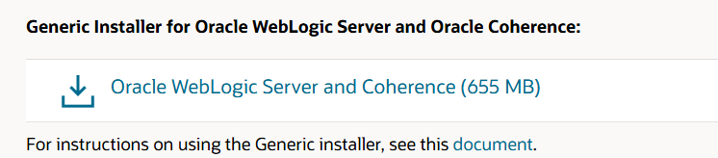

Click on the link, it takes you to below page, there you select the platform windows, accept the license and click on the download, it must look as below

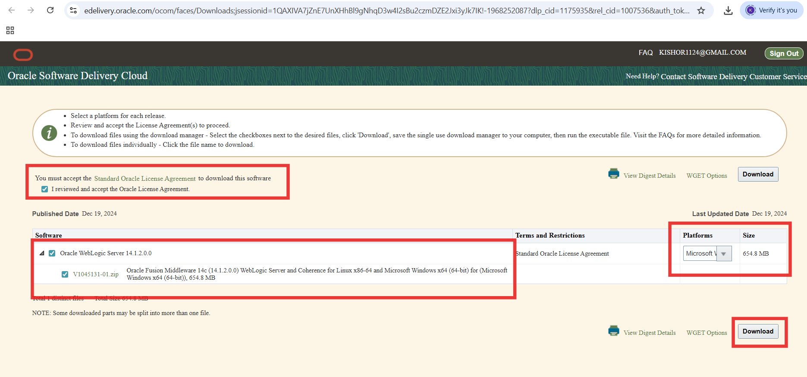

Note: If it asks you to login to the account, login so that download starts, if the account is not present you must create an oracle account.

Once the download completes you see below file



Double click on it

You get the below wizard

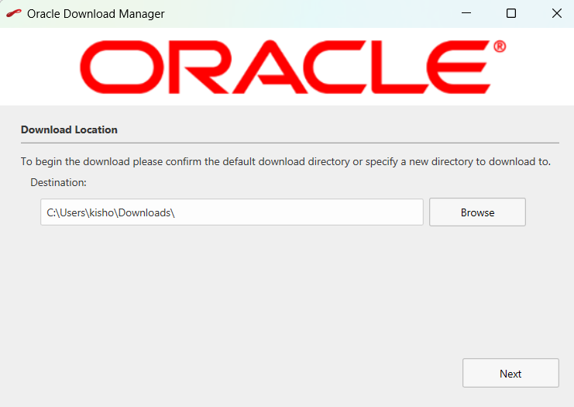

Click Next

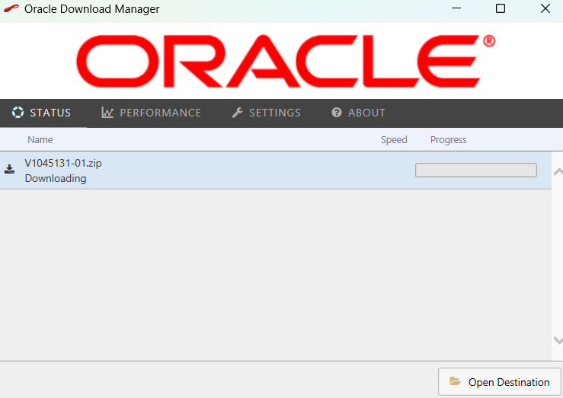

It starts downloading the WebLogic server installer wait for the process to complete

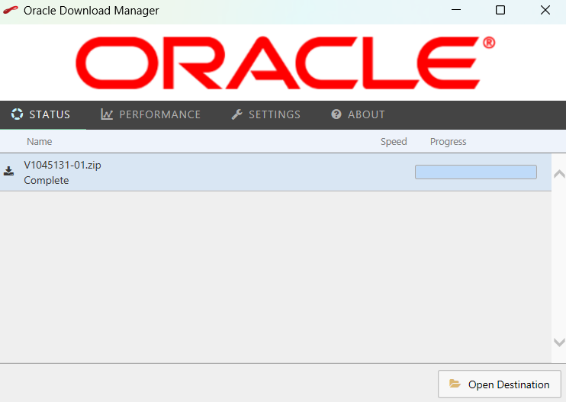

Once download completes you can click on Open Destination where you will see below zip file



Extract the zip where you will see a jar as below

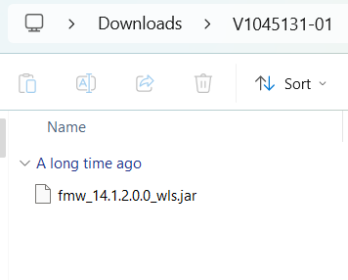

Bring the open command prompt as admin & bring to the location where this jar is present for example the jar is inside the folder Downloads\V1045131-01, hence the command looks like below

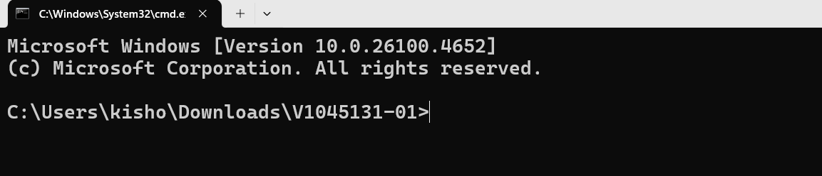

use the following command & hit enter, here you will supply the jar file name for the java -jar command

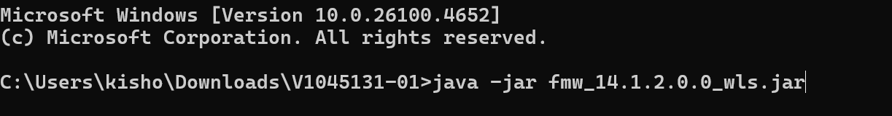

You must see the installer logs in the command prompt something like below

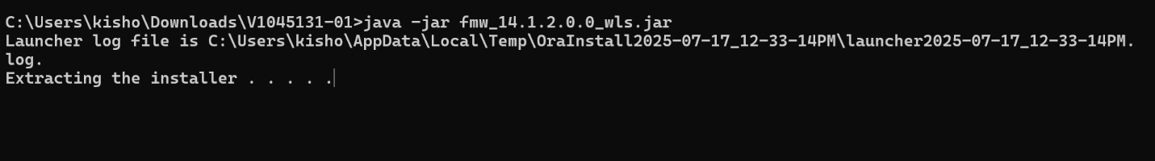

Then an installation wizard appears as below click on the Next button

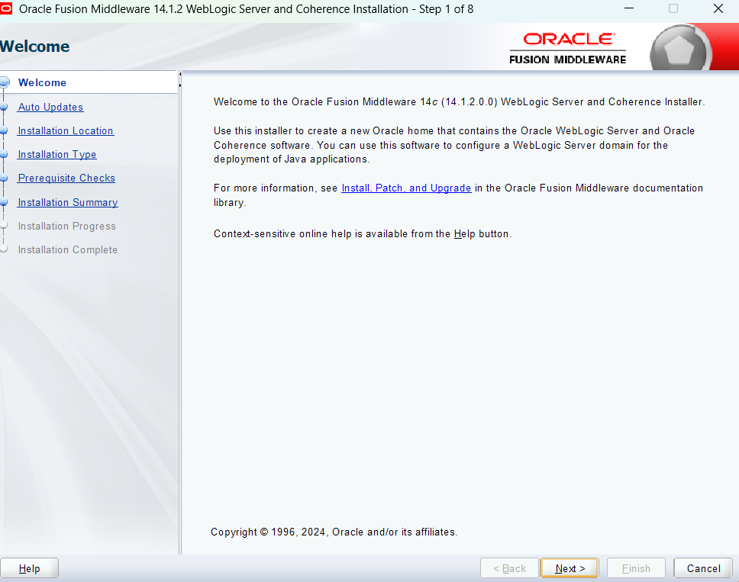

Skip auto updates & click Next

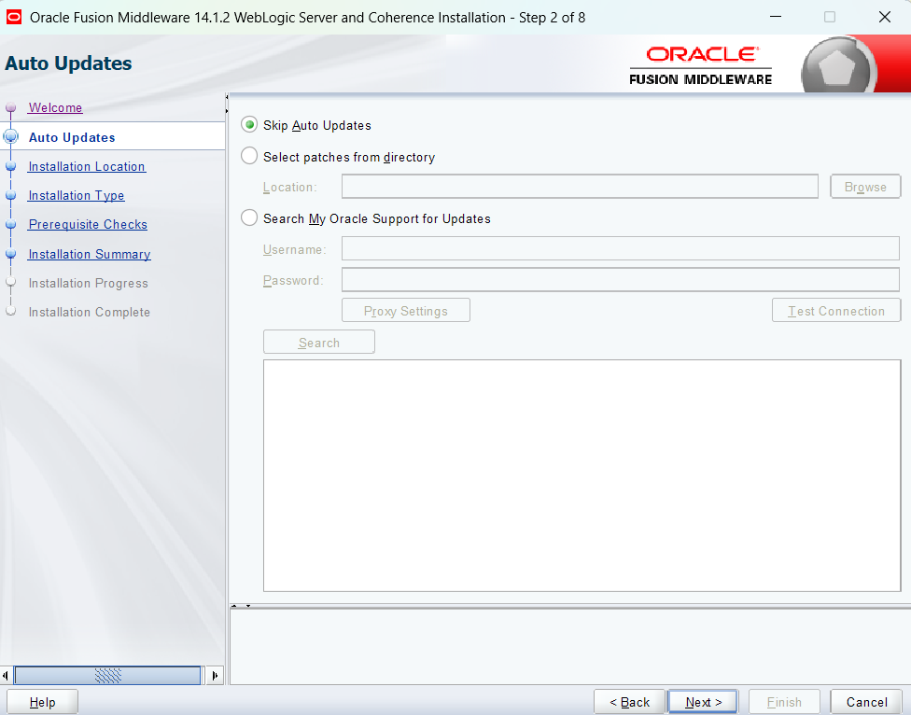

Click Next

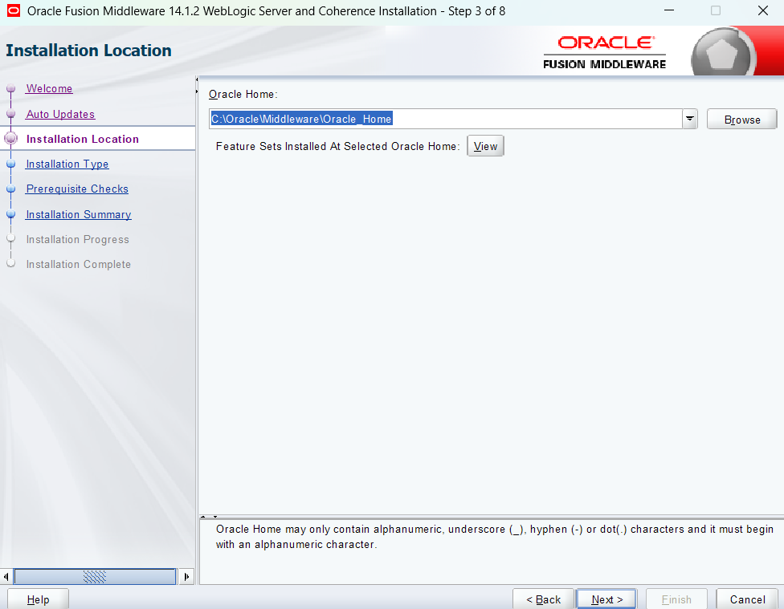

In the next wizard make sure Weblogic server is already selected if not select it and click Next

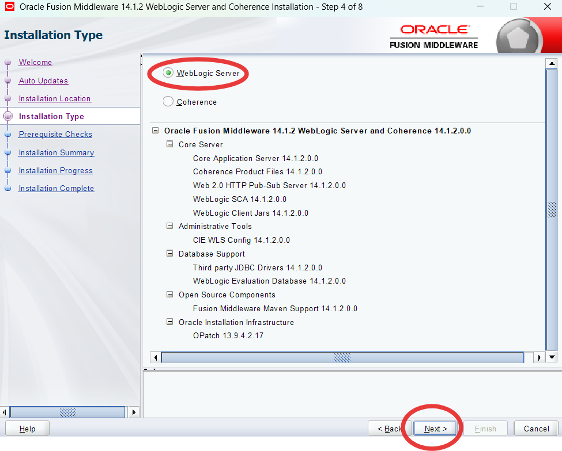

In the pre-requisites checks you get green checks, if you are getting any warning make sure you have Java 17 installed and re-do the installation of Weblogic from the beginning, if everything is fine you get below wizard

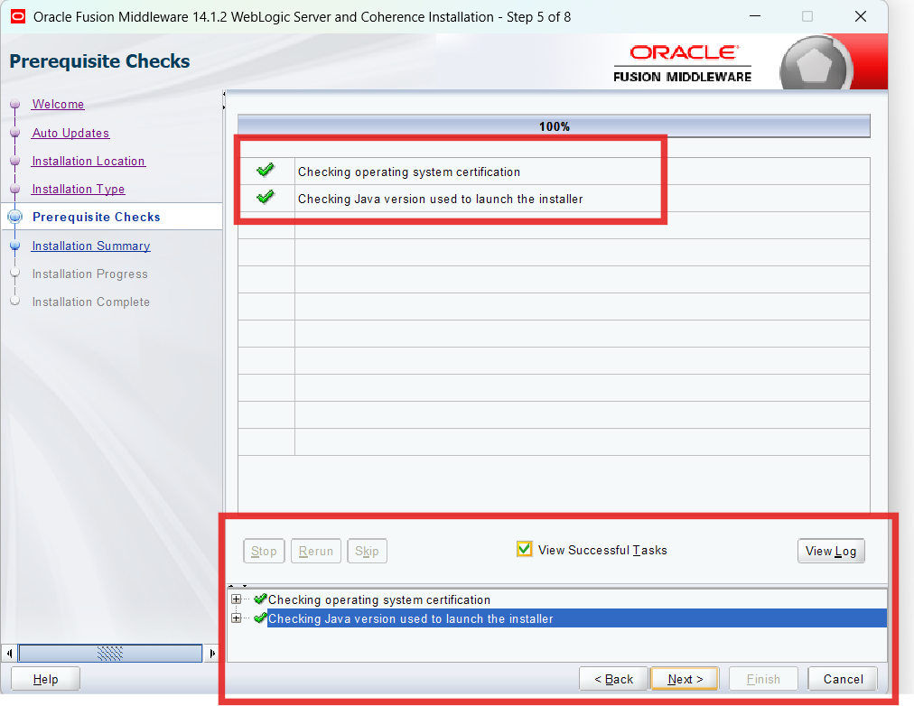

Click Next, you see the installation summary click Install button

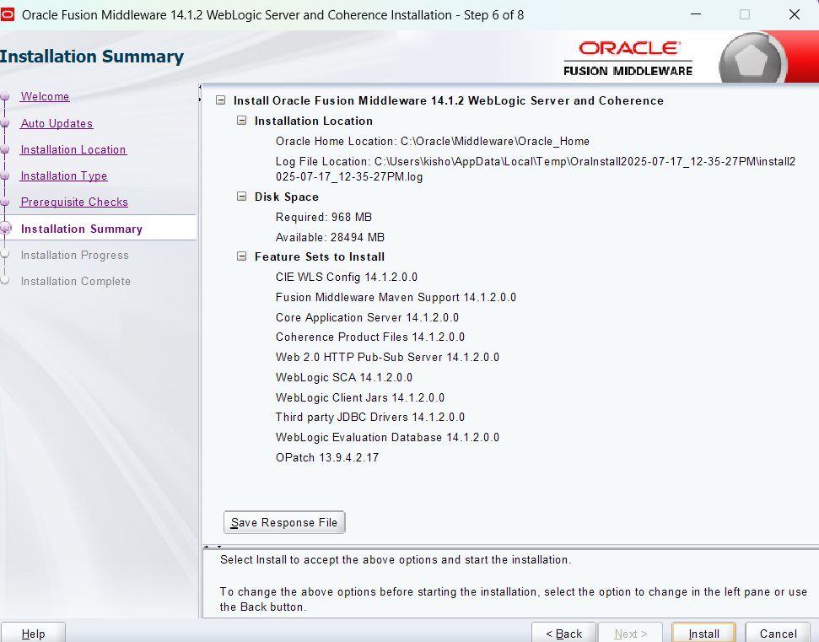

Then you will see the installation process wait for everything to complete

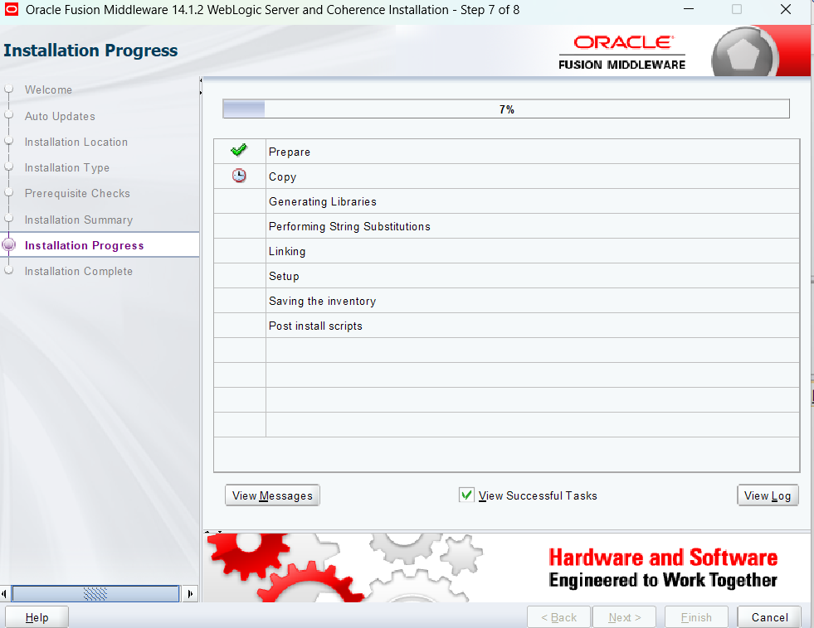

Once you see all the process completed as below

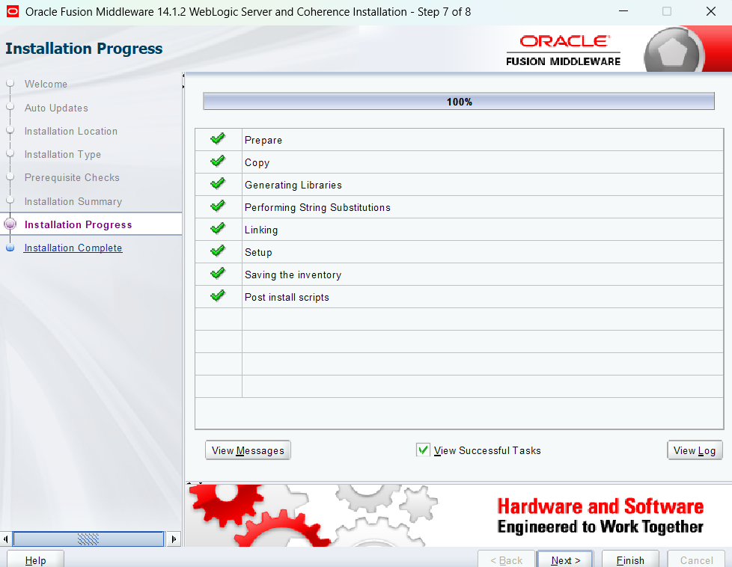

Click Next

You will see the Final wizard, make sure to uncheck Automatically Launch the configuration wizard & click Finish

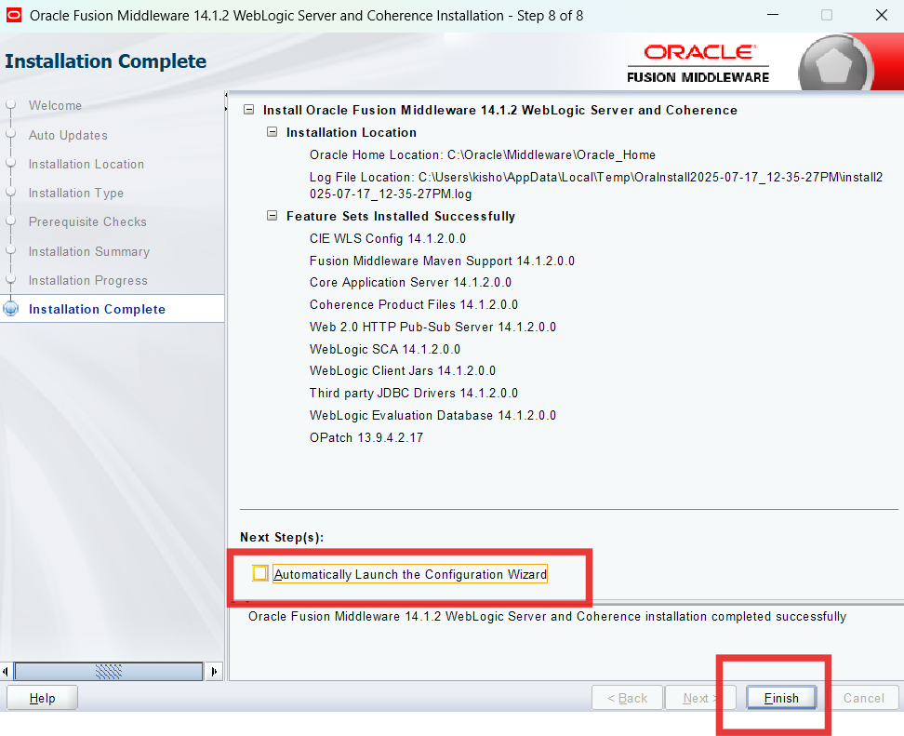

Done